# 📘 Phase 6 – Part 2A.1: Multi-Particle Dynamics

## 🎯 Goal

The objective here is to explore how multiple test particles evolve under the ψ-generated gravitational field defined by

$$Gravity(x,t)=∇^{2}[ space(x)+time^{2} ]⋅ψ(x,t)$$

Plain text:  
Gravity(x, t) = ∇²[space(x) + time²] × ψ(x, t)

with the corresponding force:

$$Force(x,t)=-∇[Gravity(x,t)]$$

Plain text:  
Force(x, t) = −Gradient[Gravity(x, t)]

This section specifically investigates **particle clustering, dispersion, drift, and sensitivity to initial conditions** when evolving within static or asymmetric ψ fields.

## 🧭 Setup

* **Domain**: 1D space, $x∈[-10,+10]$, flat boundaries.
* **Time**: Simulated in discrete steps $t_{0}→t_{n}$.
* **ψ Field**: Sum of Gaussian wells (static in this subpart), creating a multi-well landscape.
* **Particles**: 10–100 test particles, each initialized with:
  + Position: random or clustered.
  + Velocity: $v=0$ (initially at rest).
  + Mass: unit mass (no inertia variance).

## ⚙️ Equations

Each particle $i$ has position $x_{i}(t)$. Its motion follows:

$$\frac{d^{2}x_{i}}{dt^{2}}=-∇\left[∇^{2}(space+time^{2})⋅ψ(x_{i},t)\right]$$

Plain text:  
d²xᵢ/dt² = −∇[∇²(space + time²) × ψ(xᵢ, t)]

Since:  
- Flat background:   
- Time² term is independent of space: $∇^{2}[time^{2}]=0$

Thus effectively:

$$Gravity(x,t)=β⋅ψ(x,t)$$

with constant $β$ = Laplacian of (space + time²). So the governing equation reduces to:

$$\frac{d^{2}x_{i}}{dt^{2}}=-β∇[ψ(x_{i},t)]$$

## 🌐 Example ψ Configuration

ψ is constructed as a sum of Gaussian wells:



* $A_{k}$: depth of the well
* $x_{k}$: center of the well
* $σ_{k}$: width of the well

**Example**: Three asymmetric wells at $x=-5,0,+4$, with varying depths and widths.

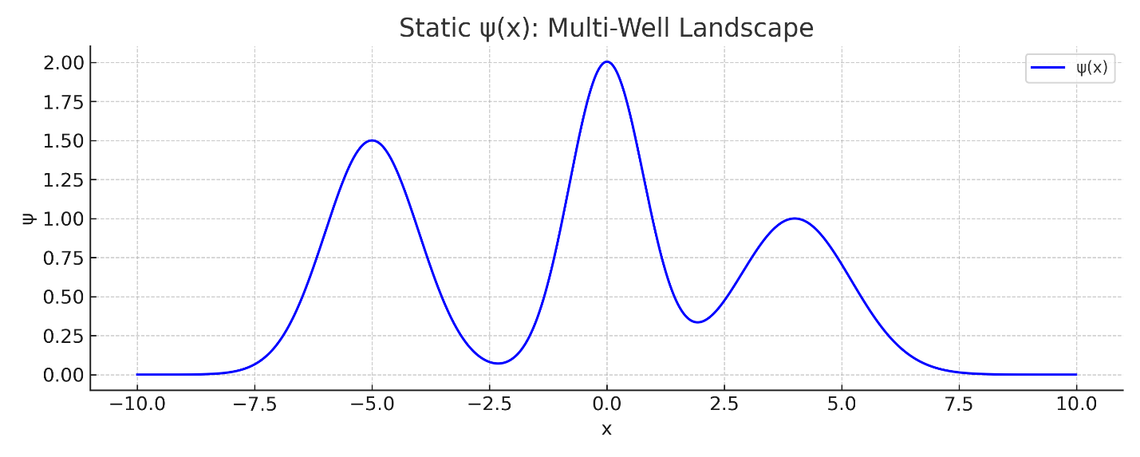

* **Caption:** *“Figure 1: Static ψ(x) multi-well landscape showing the Gaussian wells used in the simulation.”*
* **Purpose:** Visualizes the seafloor/topography (ψ wells) that drives particle motion.

## 🌊 Ocean Analogy Mapping

| Analogy Element | ψ-Gravity Mapping |
| --- | --- |
| ψ | Seafloor topology (trenches) |
| Gravity | Water pressure (from seafloor) |
| Force | Currents (tidal gradients) |
| Test particles | Fish |
| Wells | Underwater trenches (traps) |
| Asymmetry | Chaotic swirling currents |

## 🔬 Simulation Behavior

### ✅ Clustering

* Randomly scattered particles fall into nearby ψ wells.
* Favor wells with **larger depth $A$**  or **wider basins $σ$** .
* Stable clusters form near minima.

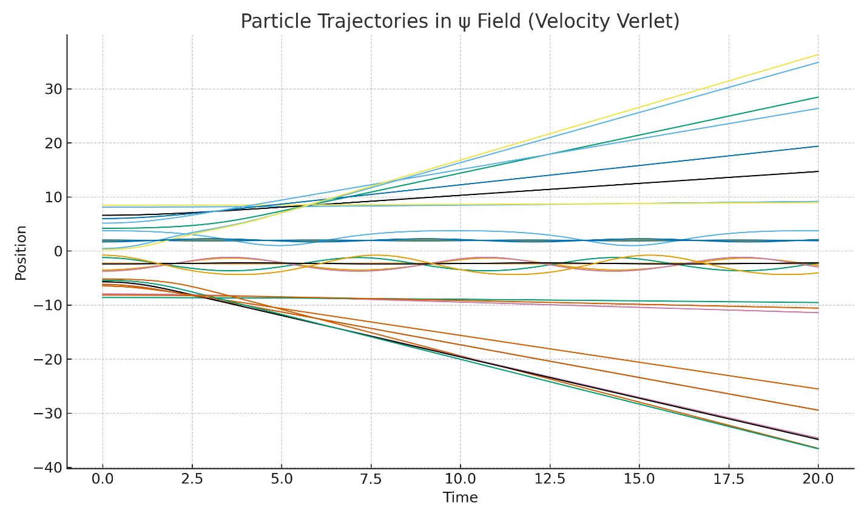

* **Caption:** *“Figure 2: Time evolution of multiple test particle positions in the static ψ field. Shows clustering into wells, drift, and path sensitivity.”*
* **Purpose:** Demonstrates how particles respond dynamically to ψ-generated forces.

### ✅ Escape / Drift

* Shallow/narrow ψ wells may:
  + Repel or eject particles.
  + Cause drift toward deeper regions.
* Some particles transition between wells via **saddle points**.

### ✅ Chaos & Path Sensitivity

* In asymmetric ψ configurations:
  + Tiny differences in initial position → diverging trajectories.
  + Delayed or accelerated capture.
  + Bifurcations (two particles in same well evolve differently).

### ✅ Binding Duration

* Track how long particles remain:
  + In a single ψ well.
  + Within an “influence zone.”
* Useful for studying **metastability** and **chaotic switching**.

## 📊 Visualization (for simulation)

1. Plot ψ(x): **blue curve** (well topology).
2. Overlay Gravity(x): **red curve**.
3. Particles: **moving dots** over time.
4. Time vs. position graph: reveals captures, escapes, and transitions.

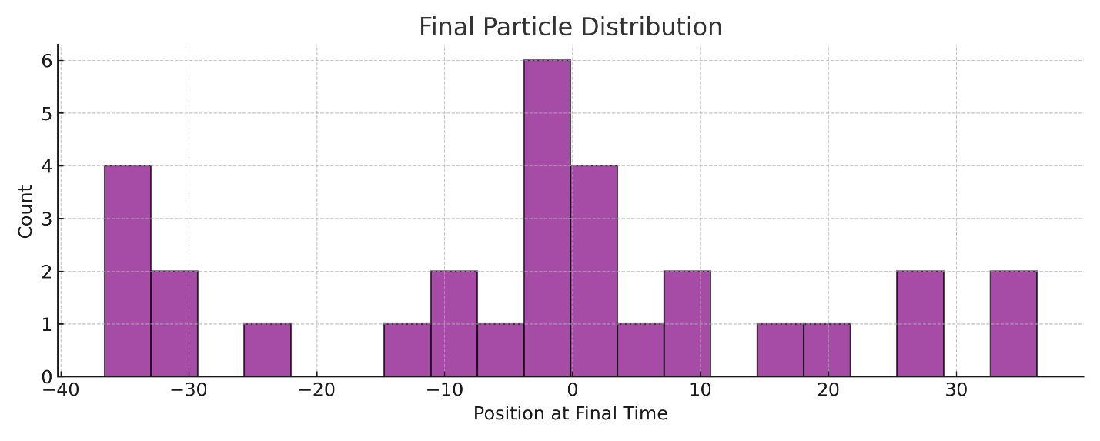

* **Caption:** *“Figure 3: Histogram of particle positions at the final simulation time, showing the occupancy of different ψ wells.”*
* **Purpose:** Summarizes particle clustering and shows the influence of well depths and widths statistically.

## 🌌 Implications

* ψ wells act as **gravitational attractors** even in static form.
* Topology of ψ directly induces:
  + Capture and clustering.
  + Drift and migration.
  + Sensitivity to initial layout.
* Demonstrates that **structure formation** can emerge purely from ψ geometry, without direct matter sources.

## ⚖️ Assumptions

* No ψ backreaction: particles do not modify ψ.
* 1D system only.
* ψ is static (time-dependent case handled later).
* Non-relativistic dynamics.

# 🌀 Extension: Dynamic ψ Field as a Gravitational Conveyor

### Example Case: Moving Gaussian ψ trench

* ψ(x, t) = Gaussian well moving right at velocity $v=0.25$.
* Particle at rest initially at $x=-5.0$.

### Observations

* **Top Plot**: ψ trench (red/blue) moves right; particle path (black) follows briefly before being left behind.
* **Middle Plot**: Particle position shows capture, drift forward, then release.
* **Bottom Plot**: Particle velocity shows wave-like push: acceleration in well, deceleration on exit.

### 🧭 Behavior

* **Capture**: ψ well gradient draws particle in.
* **Surfing**: Particle is carried along by moving trench.
* **Ejection**: Particle slips out when trench moves too far.

This validates **non-static, non-contact motion**: matter guided by ψ trench dynamics.

### 🌊 Analogy Update

| Element | Updated Interpretation |
| --- | --- |
| ψ(x, t) | Moving seafloor trench |
| Gravity | Pressure field from trench depth |
| Force | Tide gradients shifting with motion |
| Particle | Fish caught in trench motion |
| Motion Outcome | Surfing, ejection, asymmetric responses |

## 📘 Closing of Part 2A.1

* Established **multi-particle ψ dynamics** in static wells.
* Identified clustering, drift, escape, and chaos.
* Extended analysis to **dynamic ψ trenches**, confirming “surfing” motion.
* Demonstrated ψ as an **active conveyor of motion** independent of direct matter sources.

Next:  
➡️ **Phase 6 – Part 2A.2: ψ-Trench Surfing (Dynamic ψ Field Interaction)**